Project Initialization and Planning Phase
Date | 2 Dec 2025
Team ID | SWUID20250222796
Project Name | Predicting Plant Growth Stages with Environmental and Management Data Using Power BI
Maximum Marks | 3 Marks

Define Problem Statements (Customer Problem Statement Template)
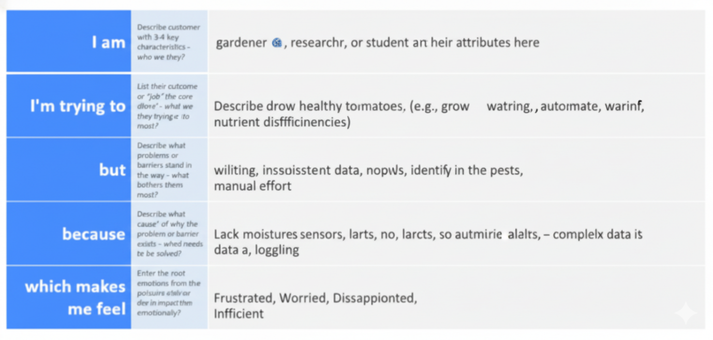
Example: 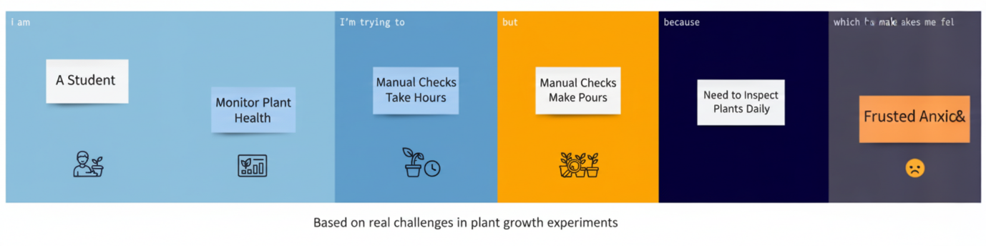

Problem Statement | I am(Customer) | I`m Trying to | But | Because | Which makes me feel
PS-1 | A Student managing an Experiment with multiple plants | Maintain Consistent Soil moisture level across all plant to Ensure, Fair, Reliable data | The manual checking and watering process it inconsistent and time consuming | Different plant absorb water at different rate and checking each for individually requires constant attention and introduce human error | Frustrated and doubtful about the validity experiments result
PS-2 | The project team analysing growth data over a month | Accurately track subtle long-term changes is paint health like easily nutrient deficiency | Visual inspection only revels problems after they have become severe | Minor Changes in leaf colour, size or texture are too small to rakishly detect and record daily without instruments | Worried and late to intervene to save the pant or gather the necessary data

